**N PARITHA BARVEEN**

**820119104011**

Cloud Computing

Smart Fashion Recommender

[barveenbintinoor@gmail.com](mailto:barveenbintinoor@gmail.com)

**ASSIGNMENT-1:**

User Registration Form

Coding-HTML,CSS

**SOURCE CODE:**

<!DOCTYPE html>

<html>

<head>

<meta name="viewport" content="width=device-width, initial-scale=1">

<style>

body{

font-family: Calibri, Helvetica, sans-serif;

background-color: dark blue;

}

.container {

padding: 50px;

background-color: lightblue;

}

input[type=text], input[type=password], textarea {

width: 100%;

padding: 15px;

margin: 5px 0 22px 0;

display: inline-block;

border: none;

background: #f1f1f1;

}

input[type=text]:focus, input[type=password]:focus {

background-color: orange;

outline: none;

}

div {

padding: 10px 0;

}

hr {

border: 1px solid #f1f1f1;

margin-bottom: 25px;

}

.registerbtn {

background-color: #4CAF50;

color: white;

padding: 16px 20px;

margin: 8px 0;

border: none;

cursor: pointer;

width: 100%;

opacity: 0.9;

}

.registerbtn:hover {

opacity: 1;

}

</style>

</head>

<body>

<form>

<div class="container">

<center> <h1> User Registeration Form</h1> </center>

<hr>

<label> Name: </label>

<input type="text" name="Name" placeholder= "" size="15" required />

<label> Email: </label>

<input type="text" name="Email" placeholder="" size="15" required />

<label> Mobile: </label>

<input type="text" name="Mobile" placeholder="" size="15"required />

<label> City: </label>

<input type="text" name="City" placeholder= "" size="15" required />

<label> State: </label>

<input type="text" name="State" placeholder="" size="15" required />

<label> Country: </label>

<input type="text" name="Country" placeholder="" size="15"required/>

<div>

<label>

<button onclick="myFunction()"><center>Submit</center></button> <p id="demo"></p>

<script> function myFunction() { let text = " Data saved"; if (confirm(text) == true) { text = "

please Wait for Response"; } else { text = "Cancelled"; }

document.getElementById("demo").innerHTML = text; } </script>

</body>

</head>

</html>

INPUT IN VISUAL STUDIO CODE:

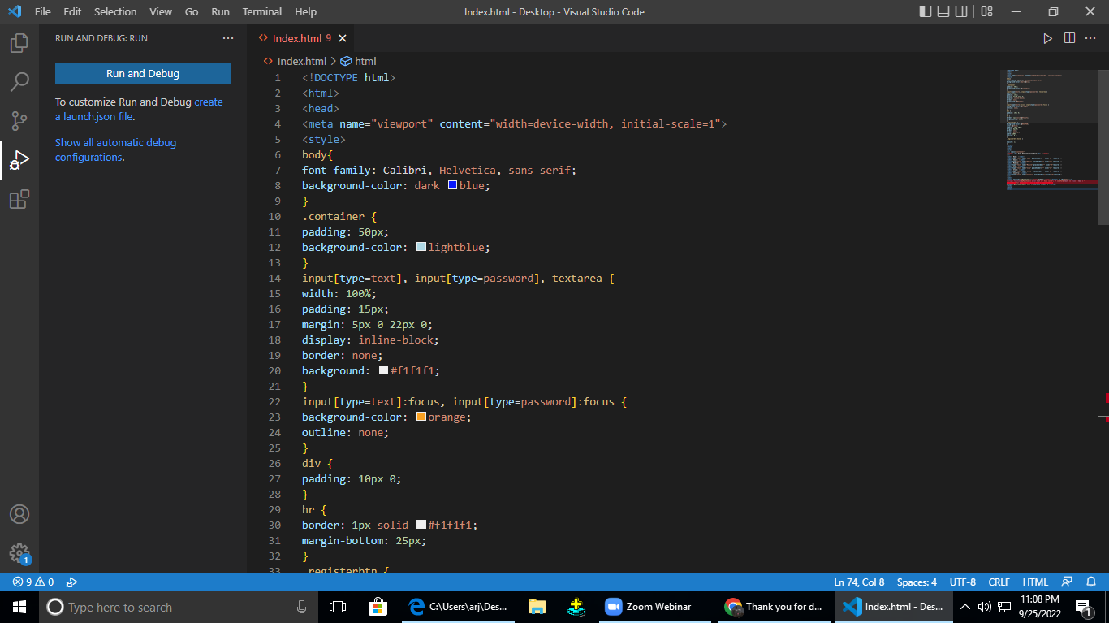

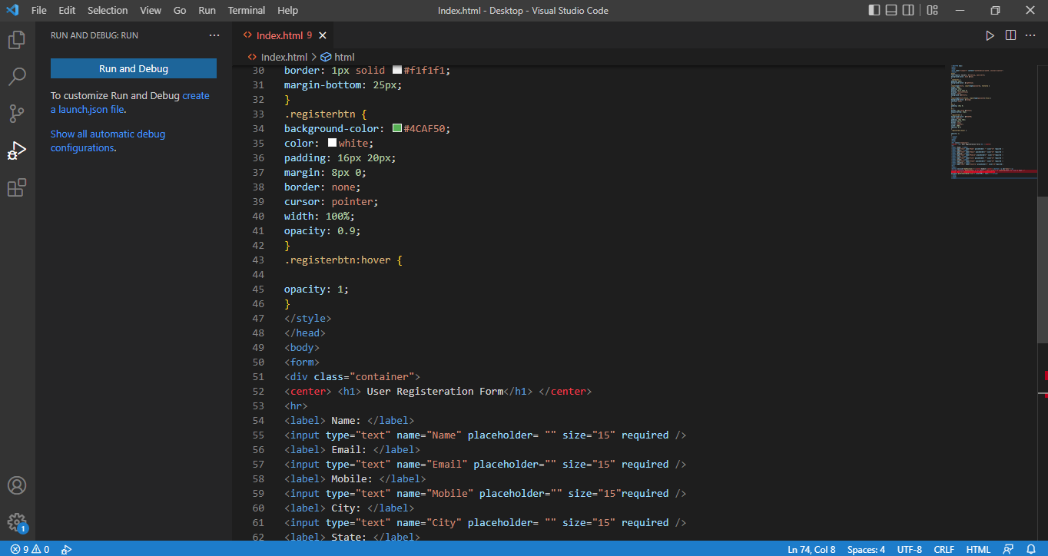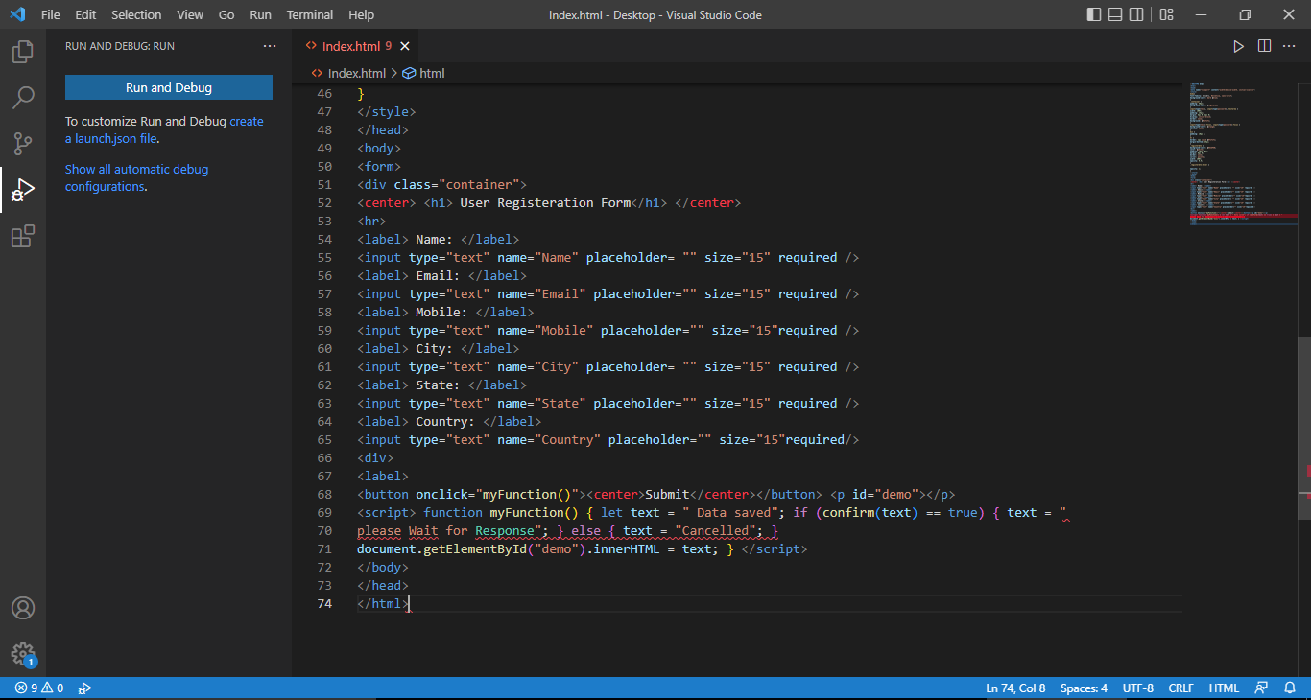

**Output from VS code:**

